QUARTERLY BUDGET STATEMENT REPORT FOR THE SECOND QUARTER ENDING DECEMBER 2023 6/1/1- (2023/2024)

Report: Municipal Manager (Chief Financial Officer)

1. PURPOSE

The report is submitted to ensure that the Executive Mayor is able to exercise his oversight responsibility over the financial management of the municipality.

1. BACKGROUND

Section 52 of the MFMA requires that:

1. The mayor of a municipality—

*(a)* Must provide general political guidance over the fiscal and financial affairs of the municipality;

*(b)* In providing such general political guidance, may monitor and, to the extent provided in this Act, oversee the exercise of responsibilities assigned in terms of this Act to the accounting officer and the chief financial officer, but may not interfere in the exercise of those responsibilities;

*(c)* Must take all reasonable steps to ensure that the municipality performs its constitutional and statutory functions within the limits of the municipality’s approved budget;

*(d)* Must, within 30 days of the end of each quarter, submit a report to the council on the implementation of the budget and the financial state of affairs of the municipality; and

*(e)* Must exercise the other powers and perform the other duties assigned to the mayor in terms of this Act or delegated by the council to the mayor.

1. DISCUSSION

The content and format of this report for the quarter ended 31 December 2023 is based upon the monthly electronic reports submitted to the Provincial and National Treasury. The statement contains the following statements:

* Statement of Operating Revenue & Expenditure – Part 1;
* Actual Capital Acquisition –Part 2;
* Cash Flow Statement – Part 3;
* Age Analysis of Debtors & Debtors Payment Statistics – Part 4;
* Age Analysis of Creditors – Part 5;
* External Investments – Part 6;
* Supply Chain Report (Deviations) – Part 7; and
* Grants & Subsidies – Part 8.

**Statement of Operating Revenue & Expenditure – Part 1**

The statement is assessed by summarizing how the municipality incurs its revenues and expenses through both operating and non-operating activities. It also shows the net profit or loss incurred over a specific accounting period.

A Profit & Loss statement provides information on the operation of the municipality. These include service charges and the various expenses incurred during the processing as well as the rendering the services

The statement is prepared on a similar basis to the prescribed budget format which details revenue by source type and expenditure by category and/or input type.

The total operating revenue for the reporting quarter amounts to R215 073 090, this amount shows a decrease of R22 607 250 comparing to prior second quarter that amounted to R237 680 340. The municipality passed credit notes on property rates, Service Charges Water and Sanitation Services, this was done to correct the incorrect billing that happened in the past. As a result of this corrections Revenue generated from these sources was lower than projected. Revenue generated from property rates R (21 811 734), electricity R116 188 304, water R16 823 832, sanitation services R5 705 227, refuse removal R7 498 628, rental income R549 380, interest earned R431 231 fines R112 870 transfer recognized – operational R55 924 000 and other revenue R331 393.

The total operating expenditure for the reporting quarter amounts to R341 013 797, this amount shows an increase of R71 956 067 comparing to the prior first quarter that amounted to R269 057 730. The amount of operating expenditure consists of employee related costs (employees) amounting to R72 723 641, bulk purchases (water and electricity) respectively R277 958 and R107 383 384, depreciation R20 665 049, finance costs R45 658 406, debt impairment R17 604 809 other materials R4 679 303, contracted services R46 450 892 and operating expenditure amounting R 21 735 045.

The operating deficit for the period amounts to (R125 940 708).



**Trading Services**



**Actual Capital Acquisition**

The actual expenditure on capital projects for the reporting quarter amounts to R15 483 716. A retention amount of R904 471.29 was released in this reporting period. The accumulated expenditure on capital projects amounts to R31 092 805.80 for the current financial year. This reflects an increase of R12 423 225.80 when compared to the expenditure of the second quarter ending in December 2022 whereby the expenditure was R18 669 580.

**Retention as at 31 December 2023**



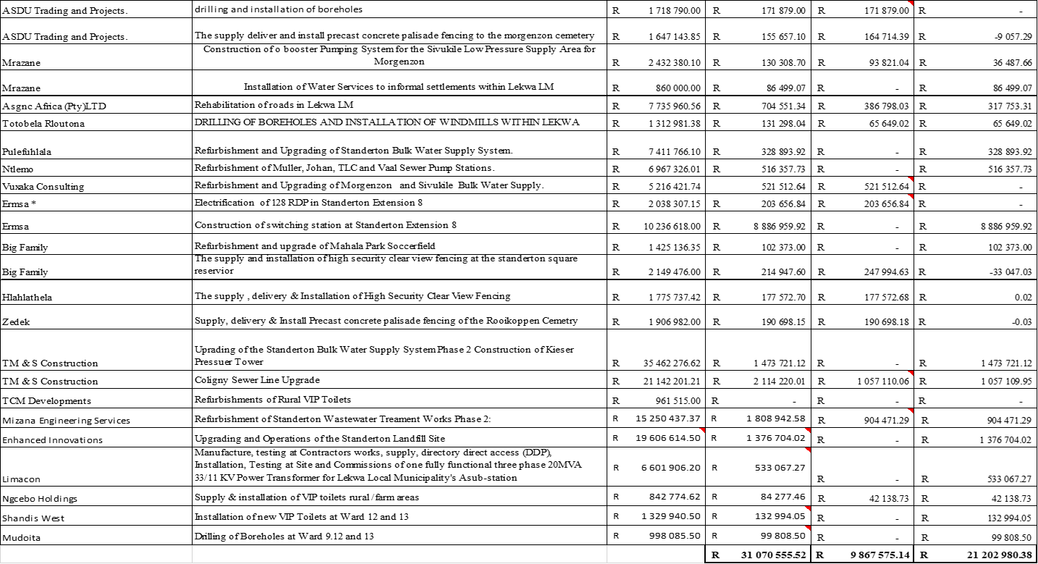

**2023/2024 Financial Year MDRG Projects**



**2023/2024 Financial Year Projects**



**Disclosure Property Plant & Equipment (Repairs & Maintenance)**



The Municipality has to date spent 39% of the total allocated budget towards repairs and maintainance. There expenditure was incurred mainly towards the repairs and maintenance of electricity network, motor, Water network, waster waste network and other PPE.

|  |  |  |  |
| --- | --- | --- | --- |
| |  | | --- | |  | |  | | ***Distribution Losses*** | |
|  |
|  |
|  |
|  |
| Municipality distribution losses on water distribution is 44% as at December 2023. |

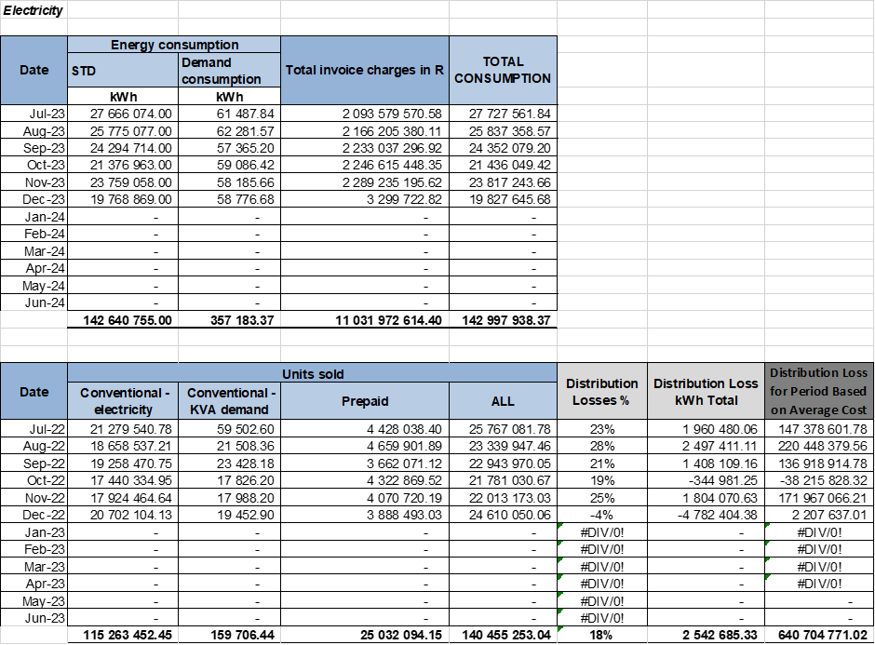

Municipality distribution losses on electricity is 18% as at 31 December 2023.

**Cash Flow Statement – Part 3**

The purpose of this statement is to keep an account of the different activities of Council. It also provides information on the mode of generation of funds required for repayment. The cash flow statement also helps to analyze the amount of cash that would be required to meet the operating costs.

It shows the expected level of cash in-flow versus cash out-flow that is likely to result from the implementation of the budget.

The actual receipt (cash) received for the reporting period amounted to R210 086 117. This reflects an increase in the revenue collected of R22 147 702 when compared to the Revenue collected of R187 938 415 for the second quarter ended in December 2022. The amount includes revenue collected from Property Rates R16 160147, Electricity R83 511 567, Water R7 925 261, sanitation R5 016 301, Refuse R2 702 040 inter accounts transfers R27 071 371, grants and subsidies: operational 56 663 000 and grants and subsidies: capital R7 540 000.

The actual payments made for the reporting period amounts to R212 448 712. This shows an increase of R38 494 896 when compared to the payment made second quarter ended December 2022 which amounted to R173 953 816. The amount includes payment for employee related costs (employees and councilors) respectively of R74 769 370 and R3 906 225, bulk purchases (water and electricity) respectively R250 000 and R12 281 919, contracted services amounting to R39 974 414 as well as inter account transfers amounting to R34 281 339 Capital expenditure amounted to R16 742 520. and general expenses amounted to R25 032 884.

The Municipality’s cash flow status for all bank accounts a favorable bank balance of R4 076 286 including a favorable closing balance on primary account of R1 766 458. It should be noted that though the municipality has a favorable bank balance at the end of the reporting month there were still outstanding creditors of R2 903 267 261.61 as disclosed on the creditors age analysis below and outstanding debtors of R1 959 226 954.



**External Investment (Call accounts)**

The Closing balance on all call accounts as at 31 December 2023 amounts to R21 101 430.60. Municipality for the reporting quarter capitalized R65 421.36 interest on all call accounts. Year to date Interest as at 31 December 2023 amounts to R431 230.50.



**Debtors Age Analysis & Debtors Payment Statistics – Part 4 a & b**

The debtor’s age analysis analyses amounts owed by customers for services rendered by the municipality according to the length of time that those amounts have remained unpaid.

The debtors’ balance has increased by R200 million from R 1,7 billion to R1,9 billion when compared to the second quarter ending December 2022. Outstanding Debtors that are older than 90 days amounts to R1,8 billion of the total outstanding debts.

The debtors balance for the reporting quarter amount to R1 959 226 954.76. The debt from households amounts to R1.4 billion, government to R 72 million while business owed R216 million, and other customers owed an amount of R 217 million. Electricity contributes R275 million of the outstanding debt, Property assessment rates R369 million, Water R334 million, Wastewater R175 million, refuse R134 million the income from other sources R132 million while interest on arrears amounts to R 536 million.



**Debtors Breakdown per Ward**

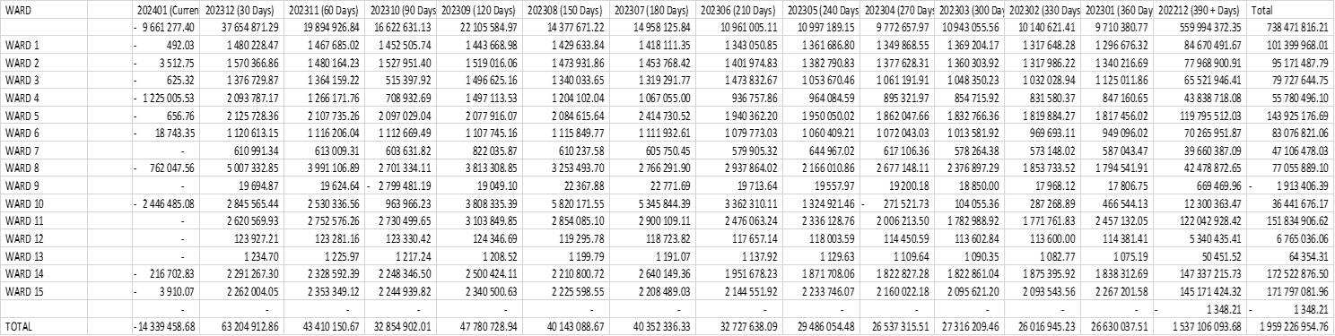

**Debtors Payment Statistics – Part 4 (b)**

The table shows the amount collected by the municipality for service rendered against the service charges billing.

The average collection rate for the second quarter ending December 2023 is 82%, taking into account the levied amount of R170 508 536.58 and the actual payments amounting to R140 467 026.77. The average collection rate is showing an increase of 14 % when compared to the average collection for the second quarter ending December 2022 of 68%.



**Payment Statistics Revenue Streams**



In an effort to ensure that there is a continuous implementation of debt collection, a plan should be developed that will focus on the various categories of customers (business, residential, government, farms etc) with a clear time frames and clear activities to be embarked on. The plan should also include the various resources required (human resources, vehicles, machinery & equipment, etc.) to enable the implementation of debt collection.

An area of concern is the high litigation and court interdict against the Municipality for illegally disconnecting customers. A procedure manual should be developed in line with credit control & debt collection policy that will outline activities that needs to be performed prior a customer is disconnected or handed over to the attorneys for collection. These activities may include amongst others issuing of notice, correcting accounts where there is an objection, addressing issues of the prescribed debt in line with the Prescription Act as well as the Municipal Systems Act.

Whilst the Municipality is implementing debt collection, it is imperative that a Customer Care Unit be established to address customer queries as well as building the consumer confidence

**Creditors Age Analysis– Part 5**

The creditors age analysis indicates an analysis of unpaid received invoices, aged by due date. The creditors are broken down into eight ageing periods.

The Creditors Age Analysis shows an outstanding amount of R2 893 143 991 of which R2 323 412 805.97 is owed to Eskom. The municipality has taken several initiatives to ensure that the arrears amount owed to Eskom is paid. The latest outstanding amount for Department of Water and Sanitation is R544 305 236.

The Provincial Head: Gauteng of the Department of water and sanitation has approved recommendations that Lekwa Local Municipality’s Register No.20016625 for the existing lawful water use (Permit No. 17/177/79) of 7 300 000m3/a be closed with effect from 2011/10/28 and that water use Licence No C11M/A/1490 issued to Lekwa Local Municipality be the only legal instrument confirming water allocation for the municipality. A recommendation that a reconciliation of the municipal account be performed and create revised bills based on the corrected volumes was also approved by the Chief Financial Officer of the department.

The Municipality’s outstanding trade creditors amounts to R8 056 267 and other trade creditors of R4 544 872. The Municipality has an outstanding payment to Auditor General an amount of R6 587 148.39. The Municipality has retention withheld amounting to R21 202 980.

The Municipality owes SARS R4 894 523.23 & R1 343 143 relating to PAYE & VAT respectively. The Municipality does not maintain sufficient working capital thus resulting in statutory payments and some other creditors not being paid timeously. The outstanding creditors are continuously increasing thus indicating that the Municipality is entering into obligations that it’s unable to service. Unless all interventions are implemented (Revenue enhancement strategy, financial recovery, cost curtailments & installation of smart meters) the Municipality will face a severe financial sustainability issues & distress, that might require the Municipality to consider interventions as entrenched within the Municipal Finance Management Act.



**Supply Chain Report (Deviations) – Part 7**

The report indicates instances where the municipality did not adhere fully to the requirements of the Supply Chain Management policy when procuring certain goods or services. Deviations approved by the Accounting Officer, do not result in the municipality over spending on the appropriated budget, neither does it reflect any fruitless, wasteful nor unauthorized expenditure. In most cases the deviations are as a result of urgent nature, sometimes limited supplies and or strip and quote situations.

For the reporting period, the Municipality did incur deviations.

**Deviations**



**Grants & Subsidies – Part 8 Received & Expenditure**

*The municipality has to date received R166 982 000.00 on the grants and subsidies as allocated.*



*The Municipality has to date spent an amount of R19 763 460.27 on conditional grants received.*



**Transfer & Grants Subsidies (Indigent support) 2**

To date 2 136 households are active on registered households for indigent support compared to a total of 1 731 for the quarter ended December 2022. The current outstanding debts balances of the registered indigent households amounted to R110 089 635.85 as at 31 December 2022, while subsidies for the current month amounted to R1 044 789.65.

|  |  |  |
| --- | --- | --- |
| **Wards No.** | **Number of Active Indigents** | **Number of Active Indigents** |
|  | **December 2022** | **December 2023** |
| Ward 1 | 146 | 154 |
| Ward 2 | 88 | 182 |
| Ward 3 | 177 | 205 |
| Ward 4 | 76 | 82 |
| Ward 5 | 185 | 225 |
| Ward 6 | 111 | 143 |
| Ward 7 | 133 | 267 |
| Ward 8 | 44 | 44 |
| Ward 9 | 0 | 11 |
| Ward 10 | 21 | 65 |
| Ward 11 | 249 | 241 |
| Ward 12 | 0 | 0 |
| Ward 13 | 0 | 0 |
| Ward 14 | 237 | 149 |
| Ward 15 | 264 | 368 |
| ' |  |  |
| **Total Indigents** | **1731** | **2136** |

**Fruitless and wasteful expenditure 3**

The Municipality was unable to pay its creditors on time resulting to interest and penalties as per the breakdown.



**Contracted Services 4**



**Debt Collection 5**

In an effort to ensure that there is a continuous implementation of debt collection, a plan should be developed that will focus on the various categories of customers (business, residential, government, farms etc) with a clear time frames and clear activities to be embarked on. The plan should also include the various resources required (human resources, vehicles, machinery & equipment, etc.) to enable the implementation of debt collection.

An area of concern is the high litigation and court interdict against the Municipality for illegally disconnecting customers. A procedure manual should be developed in line with credit control & debt collection policy that will outline activities that needs to be performed prior a customer is disconnected or handed over to the attorneys for collection. These activities may include amongst others issuing of notice, correcting accounts where there is an objection, addressing issues of the prescribed debt in line with the Prescription Act as well as the Municipal Systems Act.

Whilst the Municipality is implementing debt collection, it is imperative that a Customer Care Unit be established to address customer queries as well as building the consumer confidence.

RECOMMENDATION BY THE MUNICIPAL MANAGER (CHIEF FINANCIAL OFFICER)

1. That the Report of the Municipal Manager (Chief Financial Officer) regarding the monthly budget statement for the second quarter ending December 2023 BE NOTED.

Acknowledgement of receipt of Quarter Budget Statements (Section 52 Report) for the second quarter ending December 2023.

Municipal Manager of Lekwa Local Municipality MP305

Name: MJ Lamola

Signature: Date:

Executive Mayor of Lekwa Local Municipality MP305

Name: DL Thabethe

Signature: Date: